Southern Illinois University Edwardsville Sample Thesis
By Eddy Cougar, Bachelor of Arts

A Thesis Submitted in Partial
Fulfillment of the Requirements
for the Degree of
Master of Arts
in the field of English

Advisory Committee:
Stephen Hansen, Chair
Jerry Weinberg
Susan Morgan

Graduate School
Southern Illinois University Edwardsville
August, 2024

@ Copyright by ________Eddie Cougar________ ___August 20__
All rights reserved

ABSTRACT
Southern Illinois University Edwardsville Sample Thesis
by
EDDIE COUGAR
Chairperson: Professor Stephen Hansen

This sample thesis was created to help prevent students from having problems formatting their thesis according to the specifications in the SIUE Graduate School thesis guidelines. It is designed to show key components of a thesis to scale. Please refer back to the original thesis guidelines for more information on each piece of this sample thesis.

acknowledgements

This sample thesis could not have been completed without the work of so many people over the years refining the thesis formatting process. Thank you to whomever originally created the thesis guidelines and started theses workshops.

TABLE OF CONTENTS

ABSTRACT ii
acknowledgements iii
list of figures v
chapter i 1
thesis formatting resources 1
Overview 1
Thesis Guidelines 1
Graduate School Thesis Web Pages 2
references 3
appendices 4
A. THESIS FLOW CHART 4
b. checklist 5

list of figures

Figure 1: Thesis Guidelines 1
Figure 2: Thesis Overview Web Page 2

chapter i

thesis formatting resources

Overview
Throughout the years the Graduate School has worked to refine the thesis formatting process to make it as comprehensive and student-friendly as possible. Towards that aim, many resources have been developed to help students format their thesis as painlessly as possible.

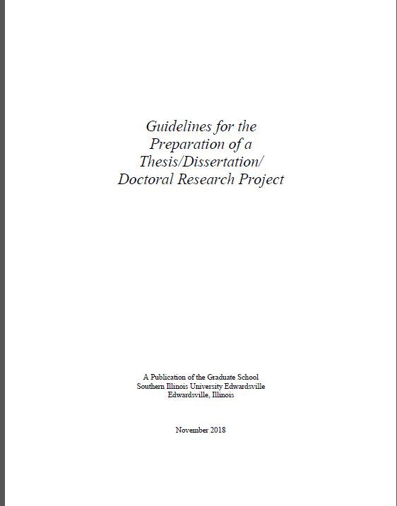
Figure 1: Thesis Guidelines

Thesis Guidelines
The thesis guidelines include detailed information on how an SIUE Graduate Student’s thesis should be formatted. Links to the guidelines are available throughout the Graduate School thesis web pages. See the guidelines for examples of headings styles, information on the manuscript thesis option, order of parts, and many more helpful instructions.
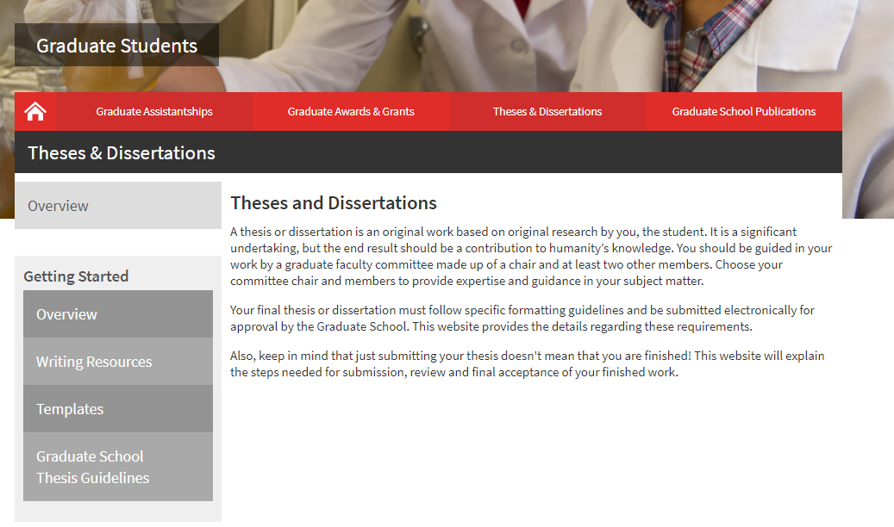
Figure 2: Thesis Overview Web Page

Graduate School Thesis Web Pages
The thesis pages available on the Graduate School web site include sections on getting started and submitting your thesis. You can also find additional tools such as an online writing boot camp module and information on thesis workshops.

references
McGuiggan, Christina M (2019). Insert Fake Book Title. London, England: Books United. This line is included just to show a hanging indent in the references.

Make sure the next entry is double spaced from the previous entry.

appendices

A: THESIS FLOW CHART

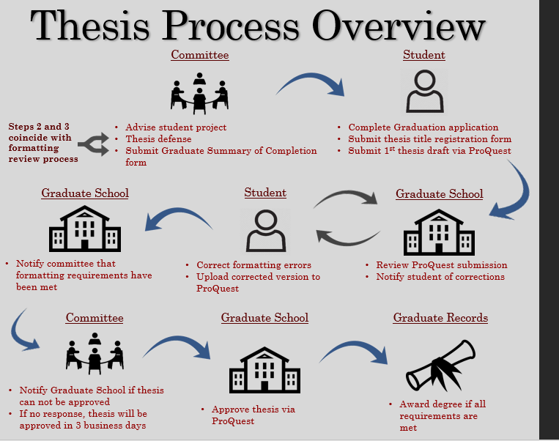

b. checklist
Graduate Student Thesis Formatting Checklist
Submitting Your Thesis to ProQuest (make sure to reference the deadlines for each term listed on the Graduate School thesis web pages http://www.siue.edu/graduate-students/theses/deadlines.shtml)
- From the Graduate School thesis page entitled “How to Submit” click on “Submit my ETD”
- Create a login using an email account that you check frequently.
  - Make sure you remember the email, password, and address you use when creating your account. If you get locked out of your account, you will need this information.
  - All communications from the Graduate School regarding your thesis formatting will come to the email address you use when creating your ProQuest account.
- Follow the steps outlined in ProQuest for submitting your thesis PDF
  - This will include paying a one-time $95 processing fee.
  - If you get stuck, you may partially complete your submission as long as you know your login and password.
  - You will NOT receive a notification from ProQuest or the Graduate School that your thesis has been submitted successfully.
Formatting Review
After you submit your thesis to ProQuest, a reviewer will be assigned to you from the Graduate School. Your reviewer will download the PDF copy of your thesis from ProQuest, compare your thesis formatting to the Graduate School guidelines, make comments on the PDF using Adobe, then register a decision via ProQuest on what your next step should be.
There are 3 decisions your reviewer could make. Here are the actions you need to take for each decision:
Major Revisions- Your reviewer has found a large amount of formatting errors OR errors that prevent the formatting from being reviewed at all (i.e. missing table of contents). Make sure to reference the Graduate School thesis guidelines for corrections that you are unsure of. Make the corrections and upload a new PDF to ProQuest in as timely a manner as possible.
Minor Revisions- Your reviewer has found a few errors. Once again, make the corrections and upload a new version to ProQuest as soon as possible. Even if there is not much to correct you still want to make sure your formatting is completed by the deadline.
Accepted- This is the final step of your formatting completion. Before the thesis is accepted in ProQuest, your reviewer will send a notification to your committee and copy you that says the formatting is done. Your committee will have an opportunity to hold off on approving if there is some reason why the thesis should not be approved. If the committee does not respond to the notice within three business days, your thesis will automatically be approved. There is no action required on your part when your thesis gets to this stage.
Common Errors to Look for Before Submitting to ProQuest
Of course, if you are trying to submit your thesis by the deadline and you know that your formatting is not complete, please go ahead and submit it. You can, however, correct the errors and upload a new version even before your reviewer has a chance to look at it. This can save a lot of time and prevent a lot of revision requests later.
The checklist on the next page is what your reviewer will be using to check your formatting, along with the Graduate School thesis guidelines.
- Overall Formatting Rules
  - Page numbers in thesis body match page numbers listed in the table of contents/lists.
  - Margins consistent, typically, one-inch on all sides, top and bottom.
  - Font type and size are the same throughout the thesis.
  - Front matter pages numbered with lower case roman numerals on the bottom center of the page/thesis body numbers in the upper right-hand corner with regular numbers (see special rules on the title page, copyright page, and the first page of the thesis body).
- Front Matter
  - Cover/Title page
    - Must match exactly with structure in the thesis guidelines.
    - Not numbered.
    - Committee members designated as PhD not Dr.
    - Graduation date current.
    - Degree level matches current degree, not the degree to be awarded.
  - Abstract
    - Numbered with a lower-case roman numeral on the bottom center of the page.
    - Matches structure in the thesis guidelines.
  - Copyright (optional)
    - Structured according to thesis guidelines.
    - Not numbered or included in the numbering scheme.
  - Table of Contents/Lists
    - Consistent formatting of 1st, 2nd, and 3rd level headings.
    - Page numbers right justified.
    - Run over lines indented.
    - Consistent spacing between headings/entries.
    - Only proper nouns and the first word capitalized on 3rd level headings.
- Body
  - First page of thesis body not numbered but included in the numbering scheme.
  - Page numbers in upper right-hand corner.
  - Page numbers for headings, tables, and figures match the table of contents/lists.
  - Table and figure labels match what are in the list of tables/figures.
  - Spacing between headings and paragraphs is consistent.
  - All chapters start on a new page.
  - Consistency throughout thesis body of 1st, 2nd, and 3rd level heading formatting.
- End Matter
  - Bibliography
    - Run over line indented.
    - Each entry single-spaced within entries and double-spaced in between entries.
  - Appendices
    - Each component clearly labeled.
    - Labels match what’s in the table of contents.
    - If only one piece, should be called “Appendix” if more than one, “Appendices”.
Graduate School Contact Information
618-650-3010
graduateschool@siue.edu
www.siue.edu/graduate

