Name: ____________________ Department: _________________________
CAS Copy Service
0226 Peck Hall
copyservice@siue.edu

Today’s date: ______________ Date/time needed: _______________
(1 business day min. / 2 business days min. for copies from books)

This order is: reading material _____ a worksheet_____ a quiz_____ an exam _____ (please check one; see note below)
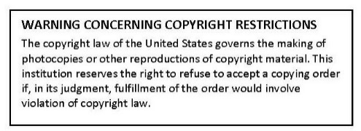
Number of Copies: ___________ If from a book, page #s:____________
Number of Originals: __________ Are originals back to back? Yes No
(the number of pages submitted; already back to back = 2 pages)
Paper Color: (please choose one)
White Yellow Pink Lilac Salmon
Blue Green Goldenrod Ivory Gray

Finishing: Collate _____ Staple _____ 3-hole punch _____
Special Instructions:

NOTE: Reading materials may not exceed 6 single pages (originals already back to back = 2 single pages) and will automatically be copied back to back. Class notes/outlines, study guides, PowerPoint slides, etc., fall into this category. Reading materials longer than 6 single pages should be placed on Blackboard. Worksheets are pages to be completed by students; they must have more than one question/problem, etc., per set or else will be treated as readings. Worksheets, quizzes, and exams may be single-sided copies; please note in Special Instructions.

CAS Copy Service
0226 Peck Hall
copyservice@siue.edu

Name: ____________________ Department: ____________________

Copy Service
0226 Peck Hall
copyservice@siue.edu

Today’s date: ______________ Date/time needed: _______________
(1 business day min. / 2 business days min. for copies from books)

This order is: reading material _____ a worksheet_____ a quiz_____ an exam_____
(please check one; see note below)
Number of Copies: ___________ If from a book, page #s:____________
Number of Originals: __________ Are originals back to back? Yes No
(the number of pages submitted; already back to back = 2 pages)
Paper Color: (please choose one)
White Yellow Pink Lilac Salmon
Blue Green Goldenrod Ivory Gray

Finishing: Collate _____ Staple _____ 3-hole punch _____
Special Instructions:

NOTE: Reading materials may not exceed 6 single pages (originals already back to back = 2 single pages) and will automatically be copied back to back. Class notes/outlines, study guides, PowerPoint slides, etc., fall into this category. Reading materials longer than 6 single pages should be placed on Blackboard. Worksheets are pages to be completed by students; they must have more than one question/problem, etc., per set or else will be treated as readings. Worksheets, quizzes, and exams may be single-sided copies; please note in Special Instructions.

